1.1 NETWORK DELAY CALCULATION TECHNICAL DESCRIPTION

Description:
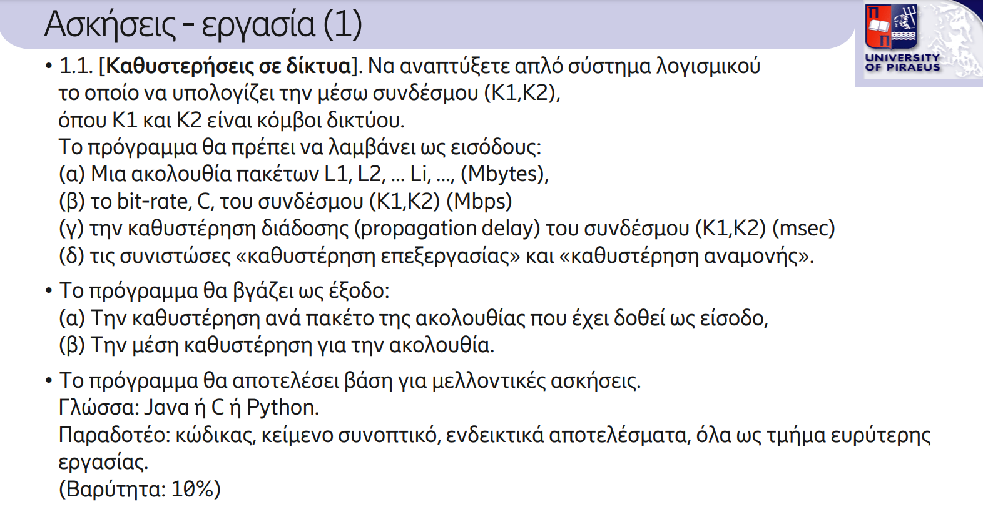

Solution:
The Network Delay Calculation Program calculates the delay for each packet and the average delay for all packets. The user must input the packet sizes (L1, L2, ..., Li), the bit rate C for transferring packets between terminals K1 and K2, the propagation delay, the processing delay, and the queuing delay.
Inputs:

Packet sizes (L1, L2, ..., Li):
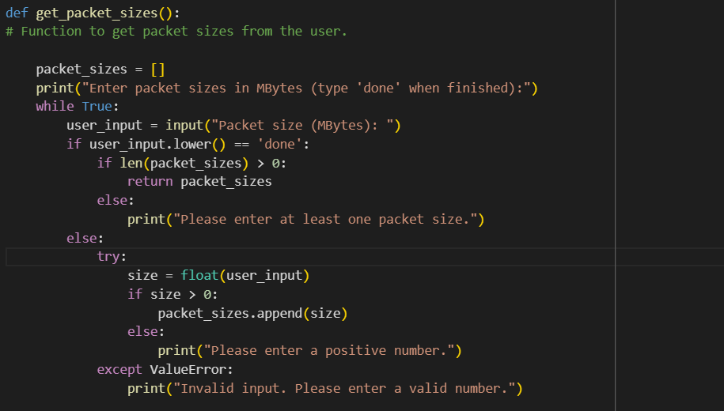
To input the packet sizes, the user must enter the size of each packet in MBytes until they type "done." If the user types "done" without entering any packets, an error message will be displayed, and the program will prompt the user to enter at least one packet before typing "done" again. The program then checks the validity of each packet size, ensuring that it is a positive number and not a string, before adding it to the list. If the user enters an invalid value, an error message will be displayed.
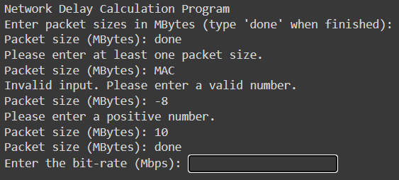
Bit Rate C - Propagation Delay - Processing Delay - Queuing Delay:
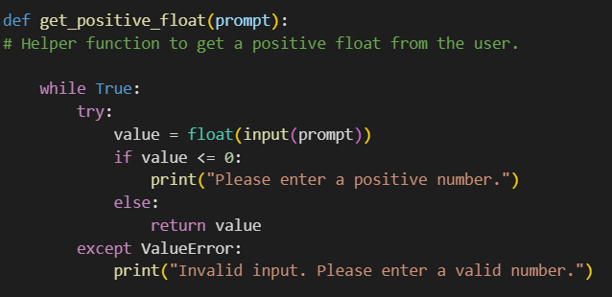
This helper function prompts the user to input a positive floating-point number. It continues to ask for input until the user provides a valid value. If the input is a non-positive number (zero or negative) or not a valid number (e.g., a string), an error message is displayed, and the user is prompted to try again.
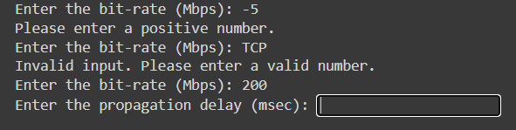

Delay Calculation:
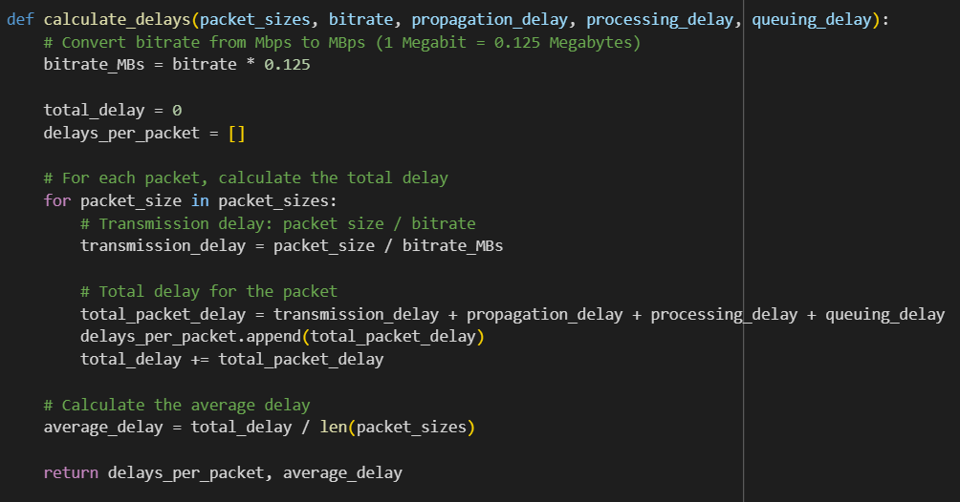
The program uses the input values to calculate the delay for each packet as well as the average delay. First, it converts the bit rate from Mbps to MBytes per second to perform the necessary calculations. For each packet, the transmission delay is computed (which is the packet size divided by the bit rate), and then additional delays (Propagation Delay, Processing Delay, and Queuing Delay) are added to the total packet delay. Each packet’s delay is stored in a list, which is later used to calculate the average delay. The average delay is determined by summing all the individual delays and dividing by the total number of packets.

Main
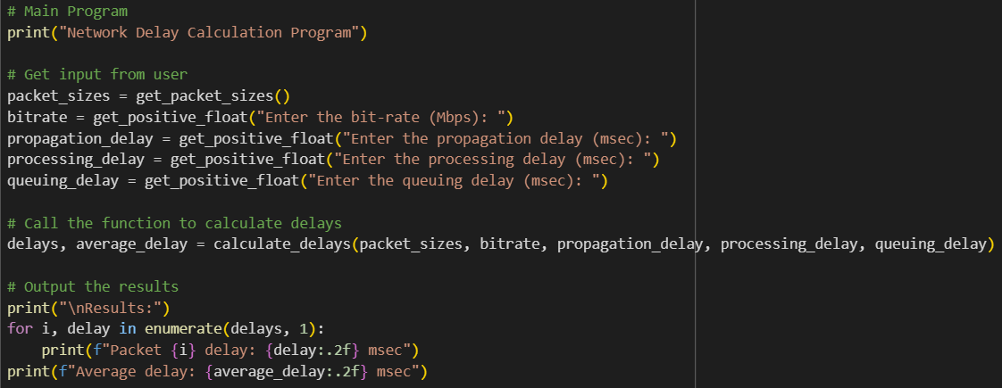
The main program uses the methods mentioned above to calculate the delays. It calls get_packet_size() to input packet sizes and get_positive_float() to correctly input the bit rate, propagation delay, processing delay, and queuing delay. Then, the total delay and average delay are calculated using the appropriate methods and stored in the main program. Finally, the results are printed.

Outputs:
